Name : Muhammad Usman

Roll Number :22i-0900

Lab 6

CREATE TABLE EMP

(EMPNO NUMERIC(4) NOT NULL,ENAME VARCHAR(10), JOB VARCHAR(9), MGR numeric(4), HIREDATE DATE, SAL numeric(7,2), COMM numeric(7,2), DEPTNO numeric(2));

CREATE TABLE DEPT

(DEPTNO numeric(2), DNAME VARCHAR(14) ,LOC VARCHAR(13));

CREATE TABLE SALGRADE

(GRADE numeric, LOSAL numeric ,HISAL numeric);

INSERT INTO EMP VALUES

(7369, 'SMITH', 'CLERK', 7902, CONVERT (date, '17-DEC-1986'),800, NULL, 20);

INSERT INTO EMP VALUES

(7499, 'ALLEN','SALESMAN',7698, CONVERT (date, '20-FEB-1981'), 1609,300, 30);

INSERT INTO EMP VALUES

(7521, 'WARD', 'SALESMAN', 7698, CONVERT (date, '22-FEB-1981'), 1250,500, 38);

INSERT INTO EMP VALUES

(7566, 'JONES', 'MANAGER', 7839, CONVERT (date, '2-APR-1981'), 2975, NULL, 20);

INSERT INTO EMP VALUES

(7654, 'MARTIN', 'SALESMAN', 7698, CONVERT (date, '28-SEP-1981'), 1250, 1460, 30);

INSERT INTO EMP VALUES

(7698, 'BLAKE','MANAGER',7839, CONVERT (date,'1-MAY-1981'), 2850, NULL, 30);

INSERT INTO EMP VALUES

(7782, 'CLARK', 'MANAGER', 7839, CONVERT (date, '9-JUN-1981'), 2450, NULL, 10);

INSERT INTO EMP VALUES

(7788, 'SCOTT','ANALYST',7566, CONVERT (date, '09-DEC-1982'), 3000, NULL, 2);

INSERT INTO EMP VALUES

(7839, 'KING', 'PRESIDENT', NULL, CONVERT (date, '17-NOV-1981'), 5000, NULL, 10);

INSERT INTO EMP VALUES

(7844, 'TURNER','SALESMAN',7698, CONVERT(date,'8-SEP-1981'), 1500, 0, 30);

INSERT INTO EMP VALUES

(7876, 'ADAMS','CLERK' ,7788, CONVERT (date, '12-JAN-1983'), 1100, NULL, 20);

INSERT INTO EMP VALUES

(7900, 'JAMES','CLERK',7698, CONVERT(date,'3-DEC-1981'), 950, NULL, 30);

INSERT INTO EMP VALUES

(7902, 'FORD','ANALYST',7566, CONVERT (date,'3-DEC-1981'), 3000, NULL, 20);

INSERT INTO EMP VALUES

(7934, 'MILLER', 'CLERK',7782, CONVERT(date,'23-JAN-1982'), 1300, NULL, 10);

-- Q1 --

Select ENAME,SAL ,SAL\*2 as 'Double SAlary' from EMP

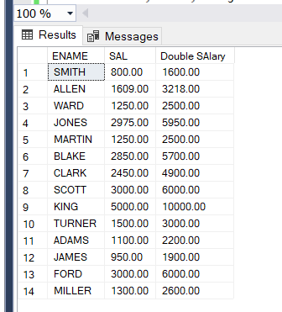

-- Q2 --

Select ENAME,SAL,JOB from EMP where COMM is null OR COMM =0

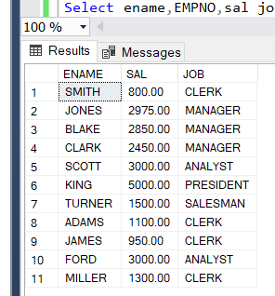

-- Q3 --

Select Distinct job from EMP

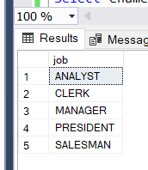

-- Q4 --

Select ename,EMPNO,sal job from EMP where ((JOB like '%MAN%') AND SAL>1500)

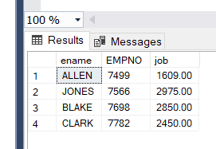

-- Q5 --

Select ENAME,job from EMP where job not in ('MANAGER', 'ANALYST','SALESMAN')

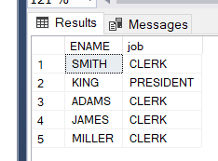

-- Q6 --

Select \* from EMP order by sal

